Beta Super Hackathon — Participant Handbook [MUST READ]
May 2 | 2nd Floor, Computer History Museum

Welcome
Welcome to the Beta Super Hackathon.
Today is designed for one goal: build something real, fast — and pitch it to top investors and operators. You’ll be working alongside high-signal builders and presenting in front of leading VCs and industry experts.
IMPORTANT: Teams retain full ownership of what they build

Communication
- Join the official Discord channel

Full Timeline

Morning (Build Phase)
- 9:00 – 9:30 AM — Check-in
- 9:30 AM — Hacking Begins
- 11:00 AM — Food Arrives

Submission Window
- 1:00 PM — Official Submission Deadline
- 1:00 – 2:00 PM — Late Submission Window
  - ⚠️ Rolling selection basis
  - ⚠️ No guarantee of demo slot after 1 PM
Team Formation
- Solo participation is fully accepted
- Team matching
  - Go to Grandhall
  - Introduce yourself
  - It’s a free forming format
- Recommended team size: 2–4 people

Hackathon Tracks
These tracks are meant to provide guidance and inspiration—they are not restrictive. You are free to explore ideas across tracks or build something completely different if that better fits your vision.
Track 1 — AI Video Agents (Vertical)
Build AI agents that automate end-to-end workflows for specific industries using video, replacing manual processes with scalable solutions like real estate walkthroughs, training content, or personalized sales videos.
Track 2 — AI Content Automation
Create pipelines that turn raw inputs such as text, data, or images into ready-to-publish video content, focusing on scalable, repeatable systems for marketing, e-commerce, or media.
Track 3 — Video DevTools
Develop tools, SDKs, or infrastructure that help developers integrate video generation into their products, improving workflows through orchestration, APIs, or multi-model systems.
Track 4 — Physical AI + Simulation
Use video generation to simulate environments or generate training data for real-world systems like robotics or autonomous agents, enabling better modeling of complex scenarios.
Track 5 — Open Track
Don’t like any of the above? Build anything you want — be creative and surprise us :)

Required Tech Stack (All the API Keys are on your Table)
- Video Generation: Seedance 2.0 (Limited Credits)
- ImaRouter: Register an account and redeem your API Keys here with our promo code (Limited for 100 Users)
  - Website: https://www.imarouter.com/
  - API: https://api.imarouter.com/
  - Config Docs: https://doc.imarouter.com/
How to Redeem your ImaRouter API Keys
  - 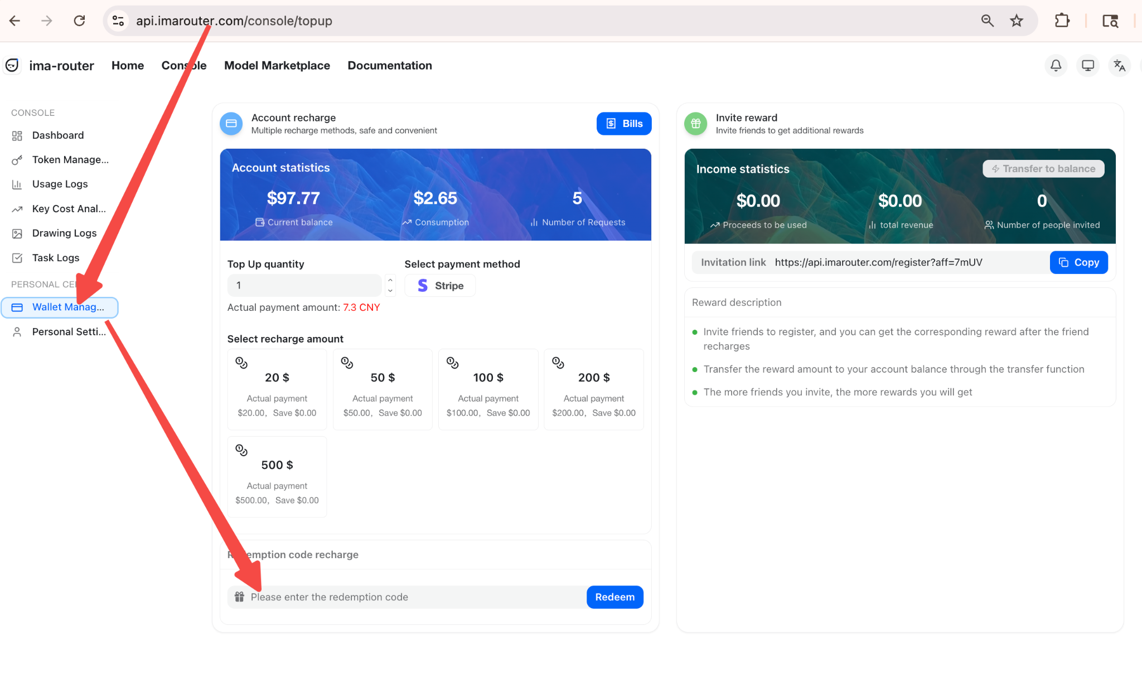
- LLM: Z.AI (Unlimited Credit)
- Deployment: Butterbase
  - With Butterbase, you can ship a live URL in under 5 minutes — no DevOps, no config. We handle your database, auth, storage, and deployment automatically so you can keep shipping.
  - Sign Up: dashboard.butterbase.ai
  - Setup: Generate your API key and follow the one-step agent setup.
  - ​​Prompt: Tell your AI agent: "With Butterbase, let's build..."
  - ​​Support: Stuck? Join Builders Club Discord #butterbase-support for live technical support.

🏆 Prizes & How to Win

Judge Awards (Primary)
- 1st Place — $5,000
- 2nd Place — $3,000
- 3rd Place — $2,000

Dimension | Wt. | The Winning Standard | Red Flags
Tech Execution | 30% | Deep API integration; autonomous agentic reasoning. | Shallow UI wrappers; hard-coded logic.
GTM & Moat | 25% | Laser-focused vertical; clear SaaO distribution. | "Video AI for everyone"; no moat.
Continuity | 20% | Scalable build; clear 7-day iteration plan. | Throwaway hacks; no roadmap.
UX Innovation | 15% | Novel, low-friction interaction paradigms. | Clunky config; high manual effort.
Demo Impact | 10% | 3-min high-signal pitch; live functional outcome. | Too much fluff; failed live demo.

Special Awards
Long-Term Product Potential — $3,000 (awarded 1 week later)
- Highest real traction after the event
- Evidence of users, retention, or continued development
- Post on discord # channel…
Social Media King — $2,000 total (4 × $500) (awarded 1 week later)
- Based on total views across social platforms
- Must include hashtags and @Beta Fund:
#betahacks #betafund #seedance
Audience Choice
- 1st — $2,000
- 2nd — $1,000
- Each attendee receives a voting form （贴过来）
- Winners determined by total votes

Most Creative Product — $2,000
- Selected by BytePlus, Beta Fund, Llama Venture
- Based on:
  - Best use of LLMs (Z.AI)
  - Best use of video generation (Seedance)
  - Novel product or interaction design
Butterbase Special Prizes
- Best Use of Butterbase: $200 Butterbase Credits
- Participant Perk: Every attendee gets $20 in credits which covers your first month on our launch plan, to kickstart their build! (Only redeemable during the hackathon)

Submission Instructions (Strict Format)
  - Submit via Butterbase
    - Submission Code: [butterbase0502]
    - Projects not built on Butterbase can still be submitted via the MCP for the hackathon. Projects built and deployed on Butterbase earn bonus points for prize consideration
  - Questions? Ask in #butterbase-support in discord
*If you haven’t set up butterbase yet, here is the set up instructions
Submission Code:[butterbase0502]

Deck Requirements (3 Slides Only)

Example from our builders:

Slide 1 — Team Introduction
- Name, school, or company
- Relevant experience
- Highlight team–problem fit
- 

Slide 2 — Product Overview
- One-line description
- One-line Problem you are solving
- One-line Solution you built
- 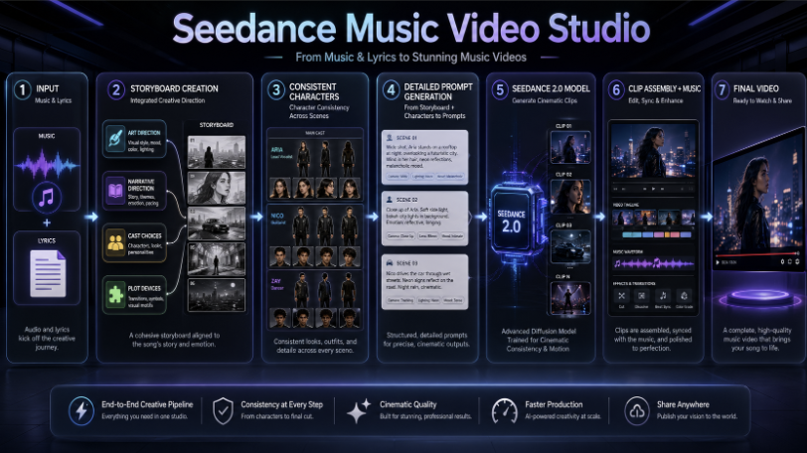

Slide 3 — Demo
Demo Example
- Video demo (max 2 minutes)
- Must show working product
⚠️ Must follow format exactly
⚠️ Non-compliant submissions may not be reviewed

✅ Submission Checklist
- Exactly 3 slides
- Video embedded (not broken link)
- File access set to “Anyone can view”
- Submitted before deadline
⚠️ Non-compliant submissions may not be reviewed

Selection Process
Top teams are selected based on:
- Submission quality
- Demo clarity
- Alignment with judging criteria
Not all submissions will be selected

Final Demo Day — Presentation Guidelines
- Selection:
  - Top teams notified by 2:00 PM
  - Includes presentation order
- Pitch Format:
  - 3 minutes total per team
  - No Q&A during pitch
- Demo Requirement (Important):
  - Only submitted video will be used
  - No live demos allowed
- Deck Handling:
  - All slides merged into one master deck
- On Stage Flow:
  - Teams called by name
  - Present immediately when called
- Attendance Requirement:
  - At least one team member must be present
  - No-show teams may be skipped
- Final demo order will be posted in Discord + on screen before Demo Day begins.

Infra & Resources
WiFi
- SSID: BetaAISuperHackathon
- Password: betafund
Power
- Outlets located near your tables
API Keys
- Provided at your table

